**Welcome to the Wonderful World of Git**

Imagine yourself as a developer building a magnificent castle (your project). But castles take time, and along the way, you might make mistakes (bugs) or want to add new features (improvements). This is where Git comes in – your trusty time machine and blueprint keeper for your code!

**What is Git?**

Think of Git as a giant, organized filing cabinet for your project's history. Every change you make – adding a new tower, fixing a broken window (code changes) – is meticulously recorded, allowing you to rewind or jump forward in time (version control).

**GitHub: The Collaboration Castle**

GitHub is like a massive online castle marketplace where developers from all over the realm can share their blueprints (repositories) and collaborate on building even grander castles (projects). You can store your project's history (Git repository) on GitHub, work with others, and borrow ideas from their castles (open-source projects).

**How Git Works: A Time-Traveling Adventure**

1. **The Working Directory:** This is your personal castle construction zone, where you make changes to the code (bricks and stones).
2. **The Repository (Remote Castle):** This is the central archive on your computer or GitHub, where Git stores all the snapshots (commits) of your castle's history.
3. **Staging Area (Staging Ground):** This is like a temporary holding area where you decide which changes from your work zone (working directory) you want to permanently save in the archive (repository).
4. **Commits (Time Capsules):** These are like snapshots of your castle at specific points in time, capturing the state of your project along with a descriptive message (like "Added a new tower" or "Fixed the drawbridge").

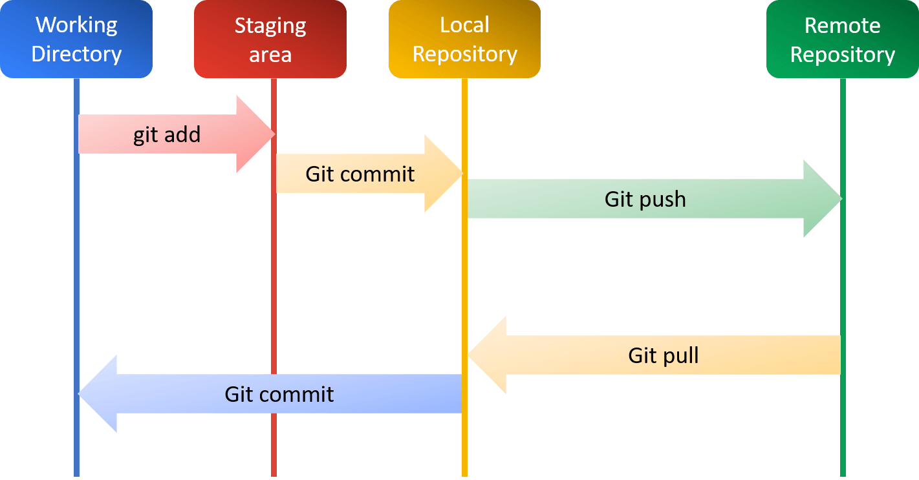

**Understanding Branches: Building Different Castle Variations**

Branches are like temporary copies of your castle blueprint. Imagine wanting to experiment with a new moat design (feature) without messing up the main castle (master branch). You can create a branch (feature branch) to make your changes, and then decide later to merge it back into the main castle (master branch) if it works well.

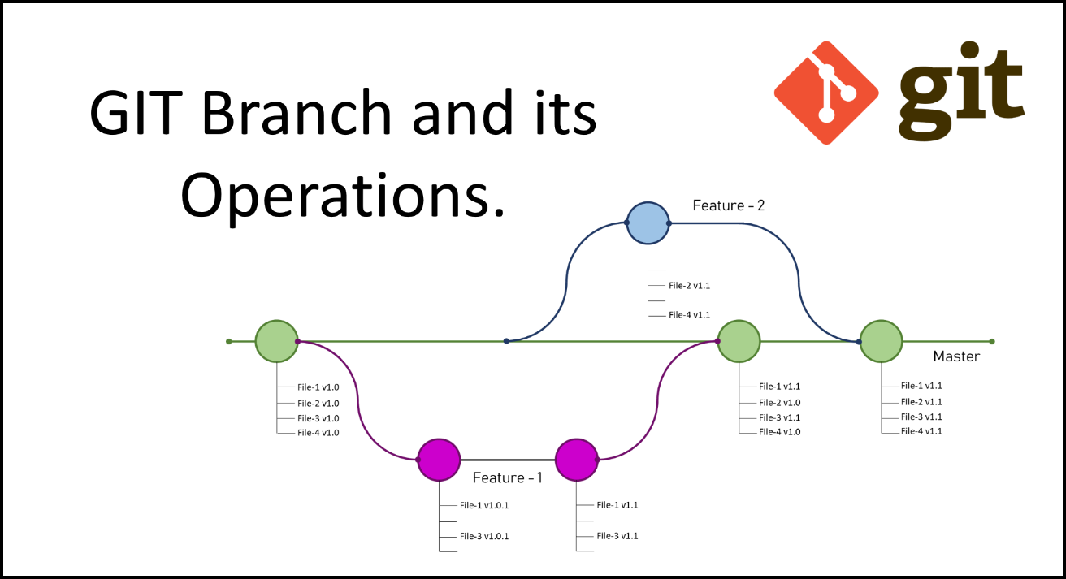

**Installing Git: Your Time Machine Toolkit**

To use Git, you'll need to install it on your computer. It's like acquiring the tools (software) to build your time machine (Git) and access the castle archive (repository).

**Installing Visual Studio Code: Your Architect's Workstation**

Visual Studio Code (or any other code editor you prefer) is your architect's desk. It's where you'll write code, interact with Git commands, and see the visual history of your castle (project).

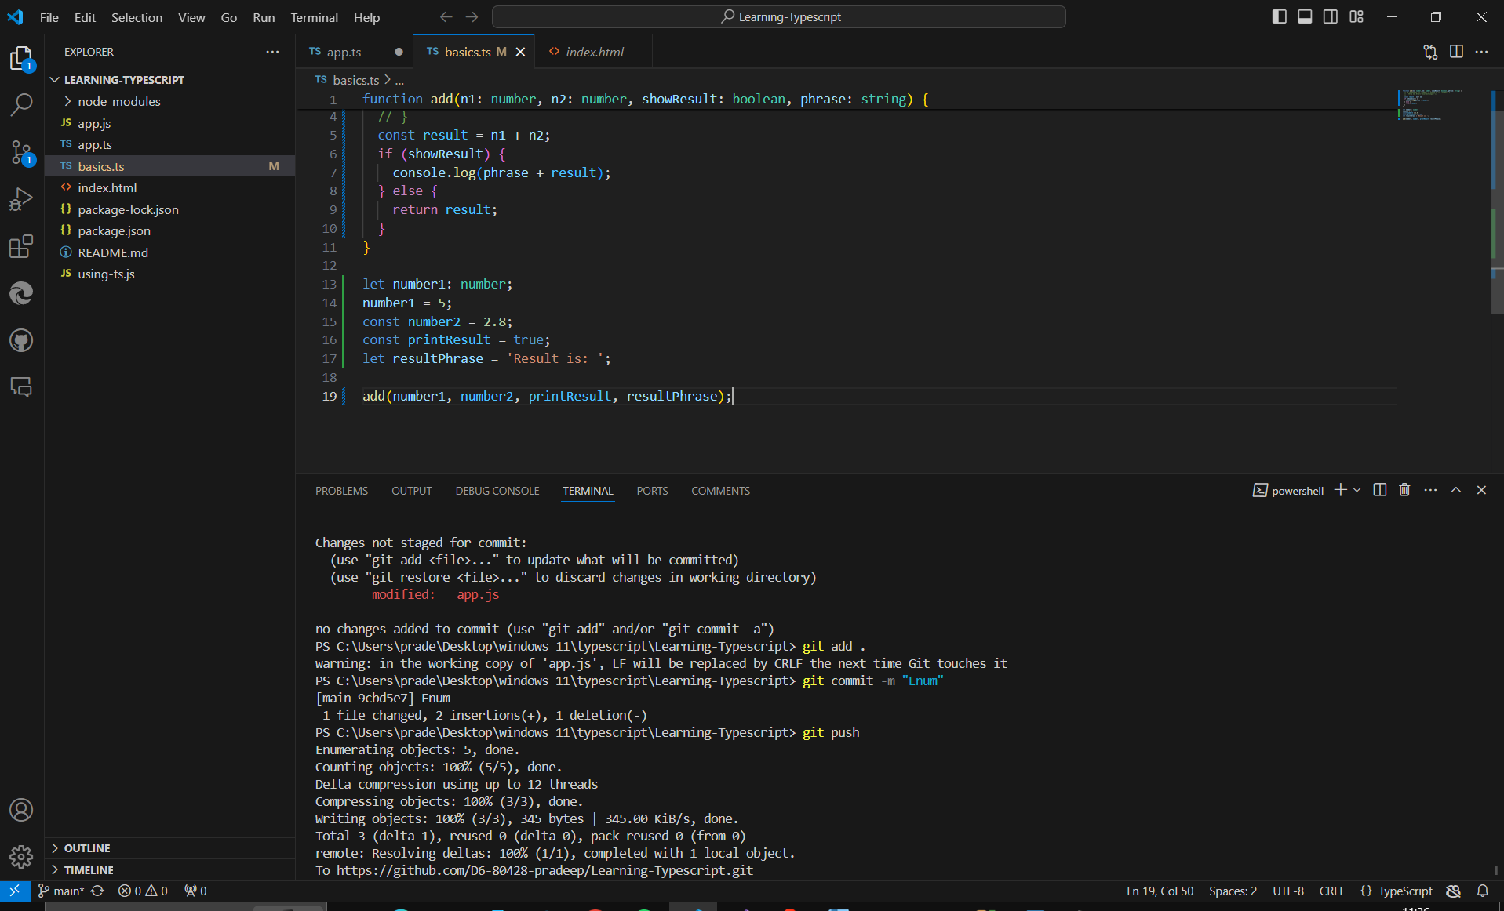



**Above screenshot is the best sample to show how we can push code to our repository and manage code using Visual studio code.**

**Initializing the Repository & Creating the First Commit (Building the Foundation)**

The git init command is like laying the foundation for your castle archive (repository) on your computer. The git commit command is like taking the first snapshot (commit) of your empty castle (initial commit message).

**Diving Deeper with git log: Your Castle's History Book**The git log command is like reading your castle's history book, showing you a list of all the commits (time capsules) with their messages, allowing you to travel back to specific points in time (versions) if needed.

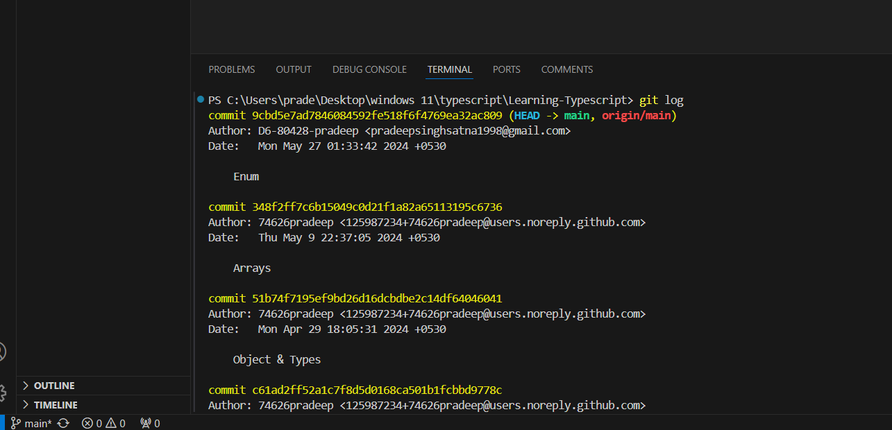



**Understanding & Creating Branches: Exploring New Designs**

To create a branch, you use the git branch <branch_name> command. Imagine this as making a copy of your current castle blueprint (master branch) to experiment with a new design (feature branch).

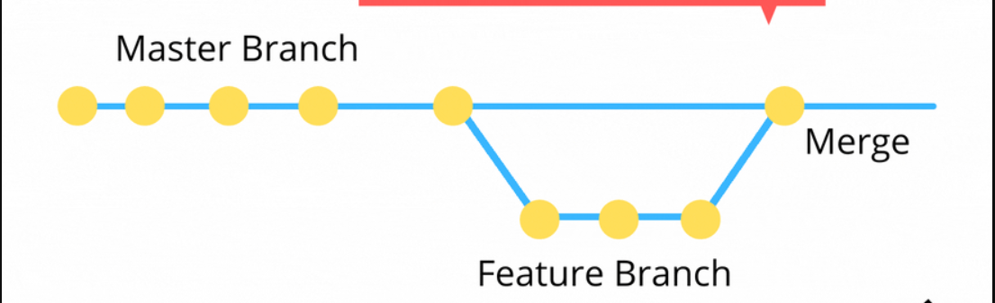

**Merging Branches: Combining the Best of Both Worlds**

Once you're happy with your changes on the feature branch, you can merge them back into the main castle (master branch) using the git merge <branch_name> command. This is like combining the best parts of your new design with the existing castle structure.

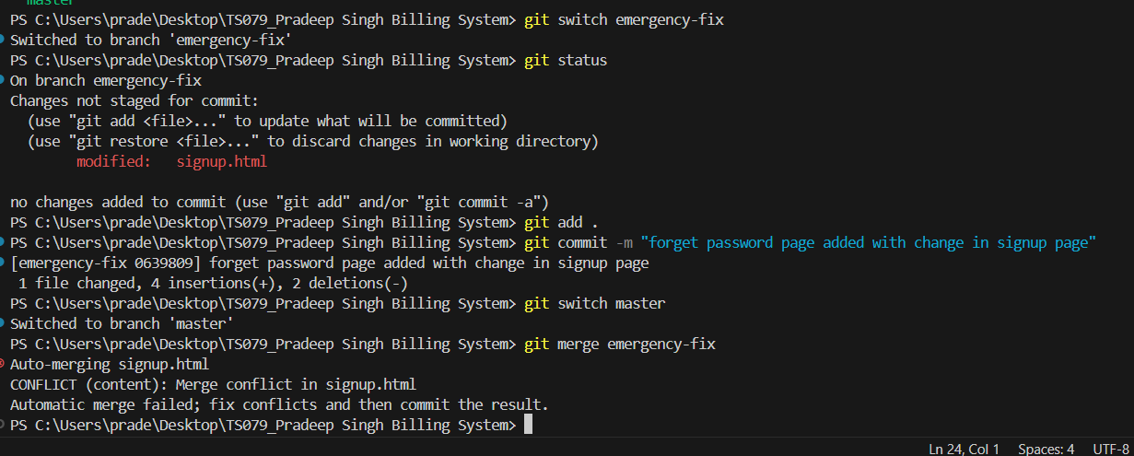



**Understanding the HEAD: Your Current Location**

The HEAD in Git refers to the pointer to the most recent commit (time capsule) you're currently working on. It's like knowing where you are in your castle's history (version control).

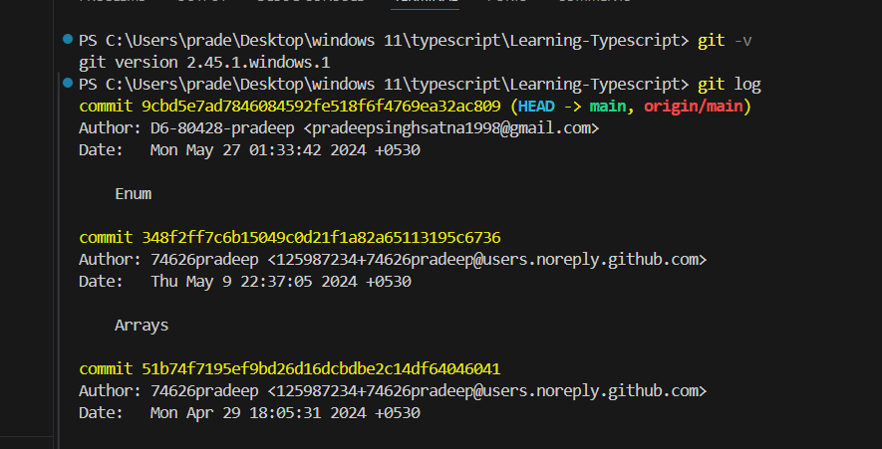

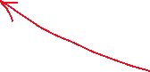

**The "Detached HEAD" State: A Temporary Stop**

Sometimes, you might detach the HEAD from a branch using specific commands. Think of this as temporarily stepping outside your castle's timeline to perform specific actions.

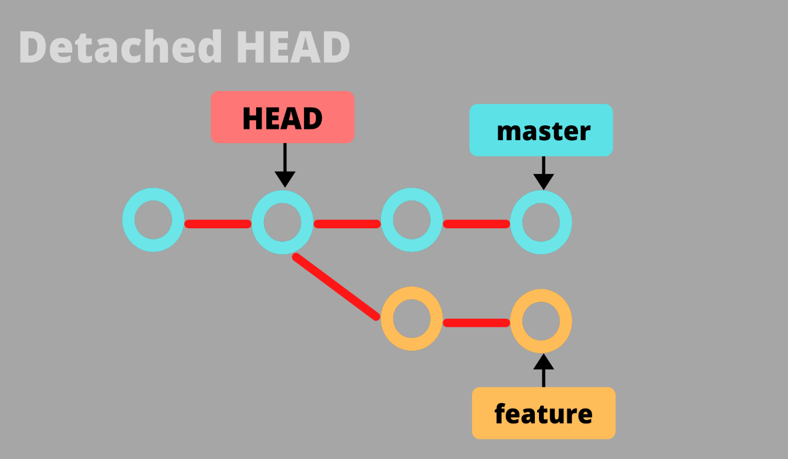

**Branches & git switch: Switching Between Designs**

The git switch <branch_name> command allows you to switch between different branches (castle designs). It's like moving from working on one part of your castle to another.

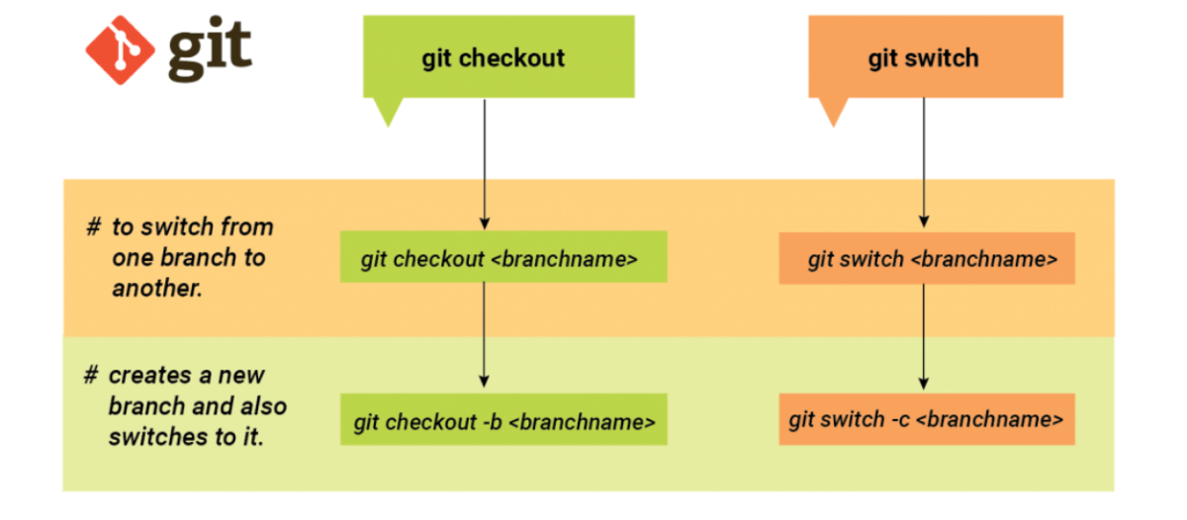

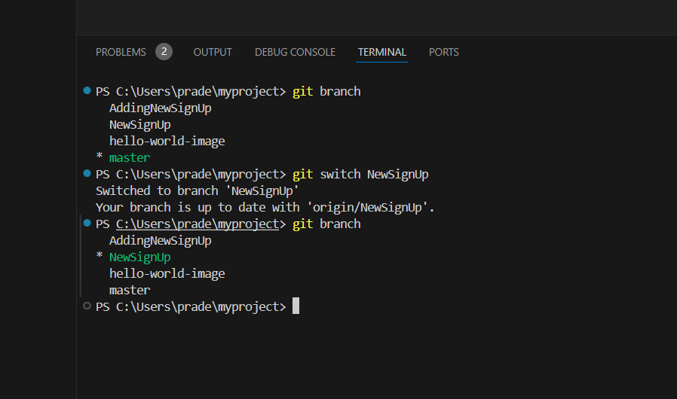

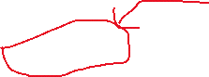

**Deleting Data: Undoing Mistakes**

Git provides ways to undo mistakes or remove unwanted changes:

* Deleting Working Directory Files: Use your operating system's commands (like rm)

Cleaning Up Your Castle: Mastering Data Deletion in Git

Sometimes, even the grandest castles need renovations. In the world of Git, deleting data can be like tidying up your construction zone and blueprints to keep your project clean and organized. Here's how you can wield the power of deletion like a skilled architect:

Deleting Working Directory Files: Removing Unwanted Bricks

Let's say you accidentally added a bunch of extra bricks (files) to your working directory (construction zone) that you don't need. You can simply use your operating system's commands (like rm on Linux/macOS or del on Windows) to remove them directly. However, these changes won't be reflected in Git history.

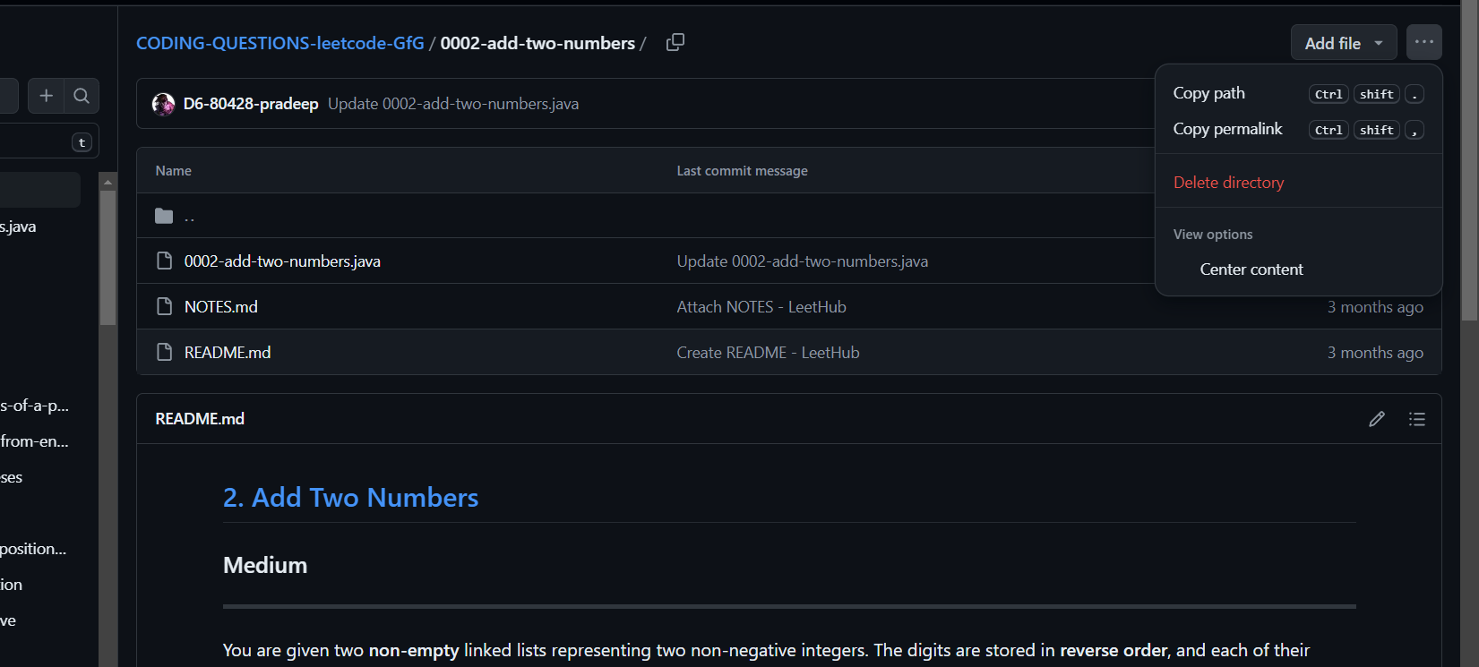

**Undoing Unstaged Changes: Changing Your Mind Before Saving**

Imagine you made some changes to your castle walls (code) but haven't yet staged them for the next commit (saved them in the blueprint archive). To undo these unstaged changes, you can use the git clean -f command. Think of it as cleaning up your workspace before finalizing the blueprints.

**Algorithm for Undoing Unstaged Changes:**

Identify the files you want to undo changes for.

Run the command git clean -f <file1> <file2>... (replace <file1> and <file2> with the actual filenames).

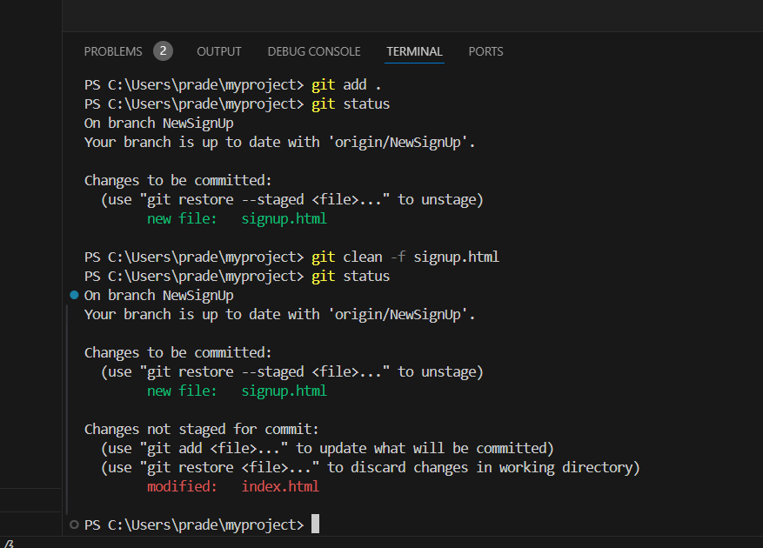



Git will prompt you to confirm the removal of unstaged changes.

**Deleting Commits with "git reset": Rewinding Time (Carefully!)**

Made a mistake in a previous commit (time capsule)? You can use git reset to rewind your castle's history (version control). However, be cautious! This permanently removes commits and can rewrite history. It's like demolishing a section of your castle and rebuilding it from scratch.

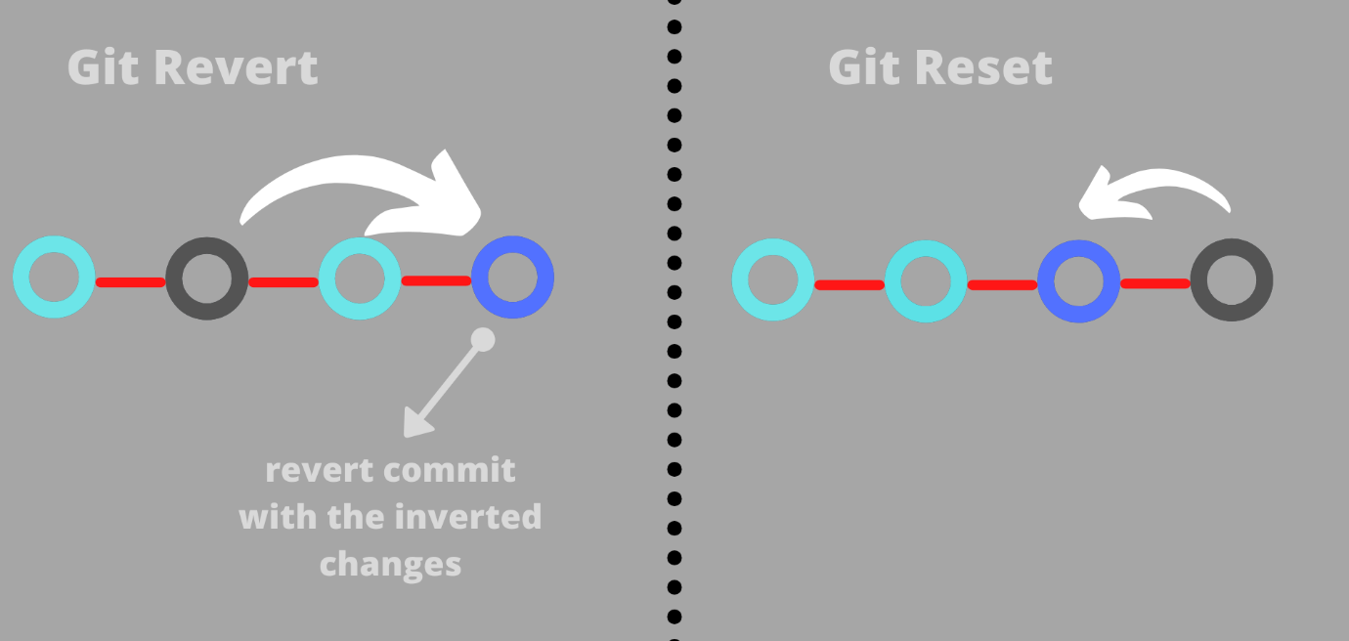

**Deleting Branches: Removing Abandoned Designs**

Let's say you created a branch (a blueprint for a new moat design) but decided not to use it. You can remove the entire branch (and its history) using git branch -d <branch_name>. Think of it as clearing away unused blueprints for a cleaner workspace.

**Algorithm for Deleting a Branch**:

Ensure you're on the branch you want to delete (use git branch).

Run the command git branch -d <branch_name> (replace <branch_name> with the actual branch name).

Git will prompt you to confirm the branch deletion.

**Committing "detached HEAD" Changes: Finalizing Unanchored Work**

In rare cases, you might find yourself in a "detached HEAD" state (temporarily outside the castle's timeline). If you've made changes in this state and want to save them, you can use git commit -m "<message>". This is like anchoring your work (commit) to a specific point in time, even if it's not part of a branch.

**Understanding. gitignore: Keeping Your Blueprints Clean**

The. gitignore file is like a "do not track" list for your castle blueprints. You can specify files or patterns (like temporary files or logs) that Git should ignore and not include in commits. This keeps your blueprints clean and organized.

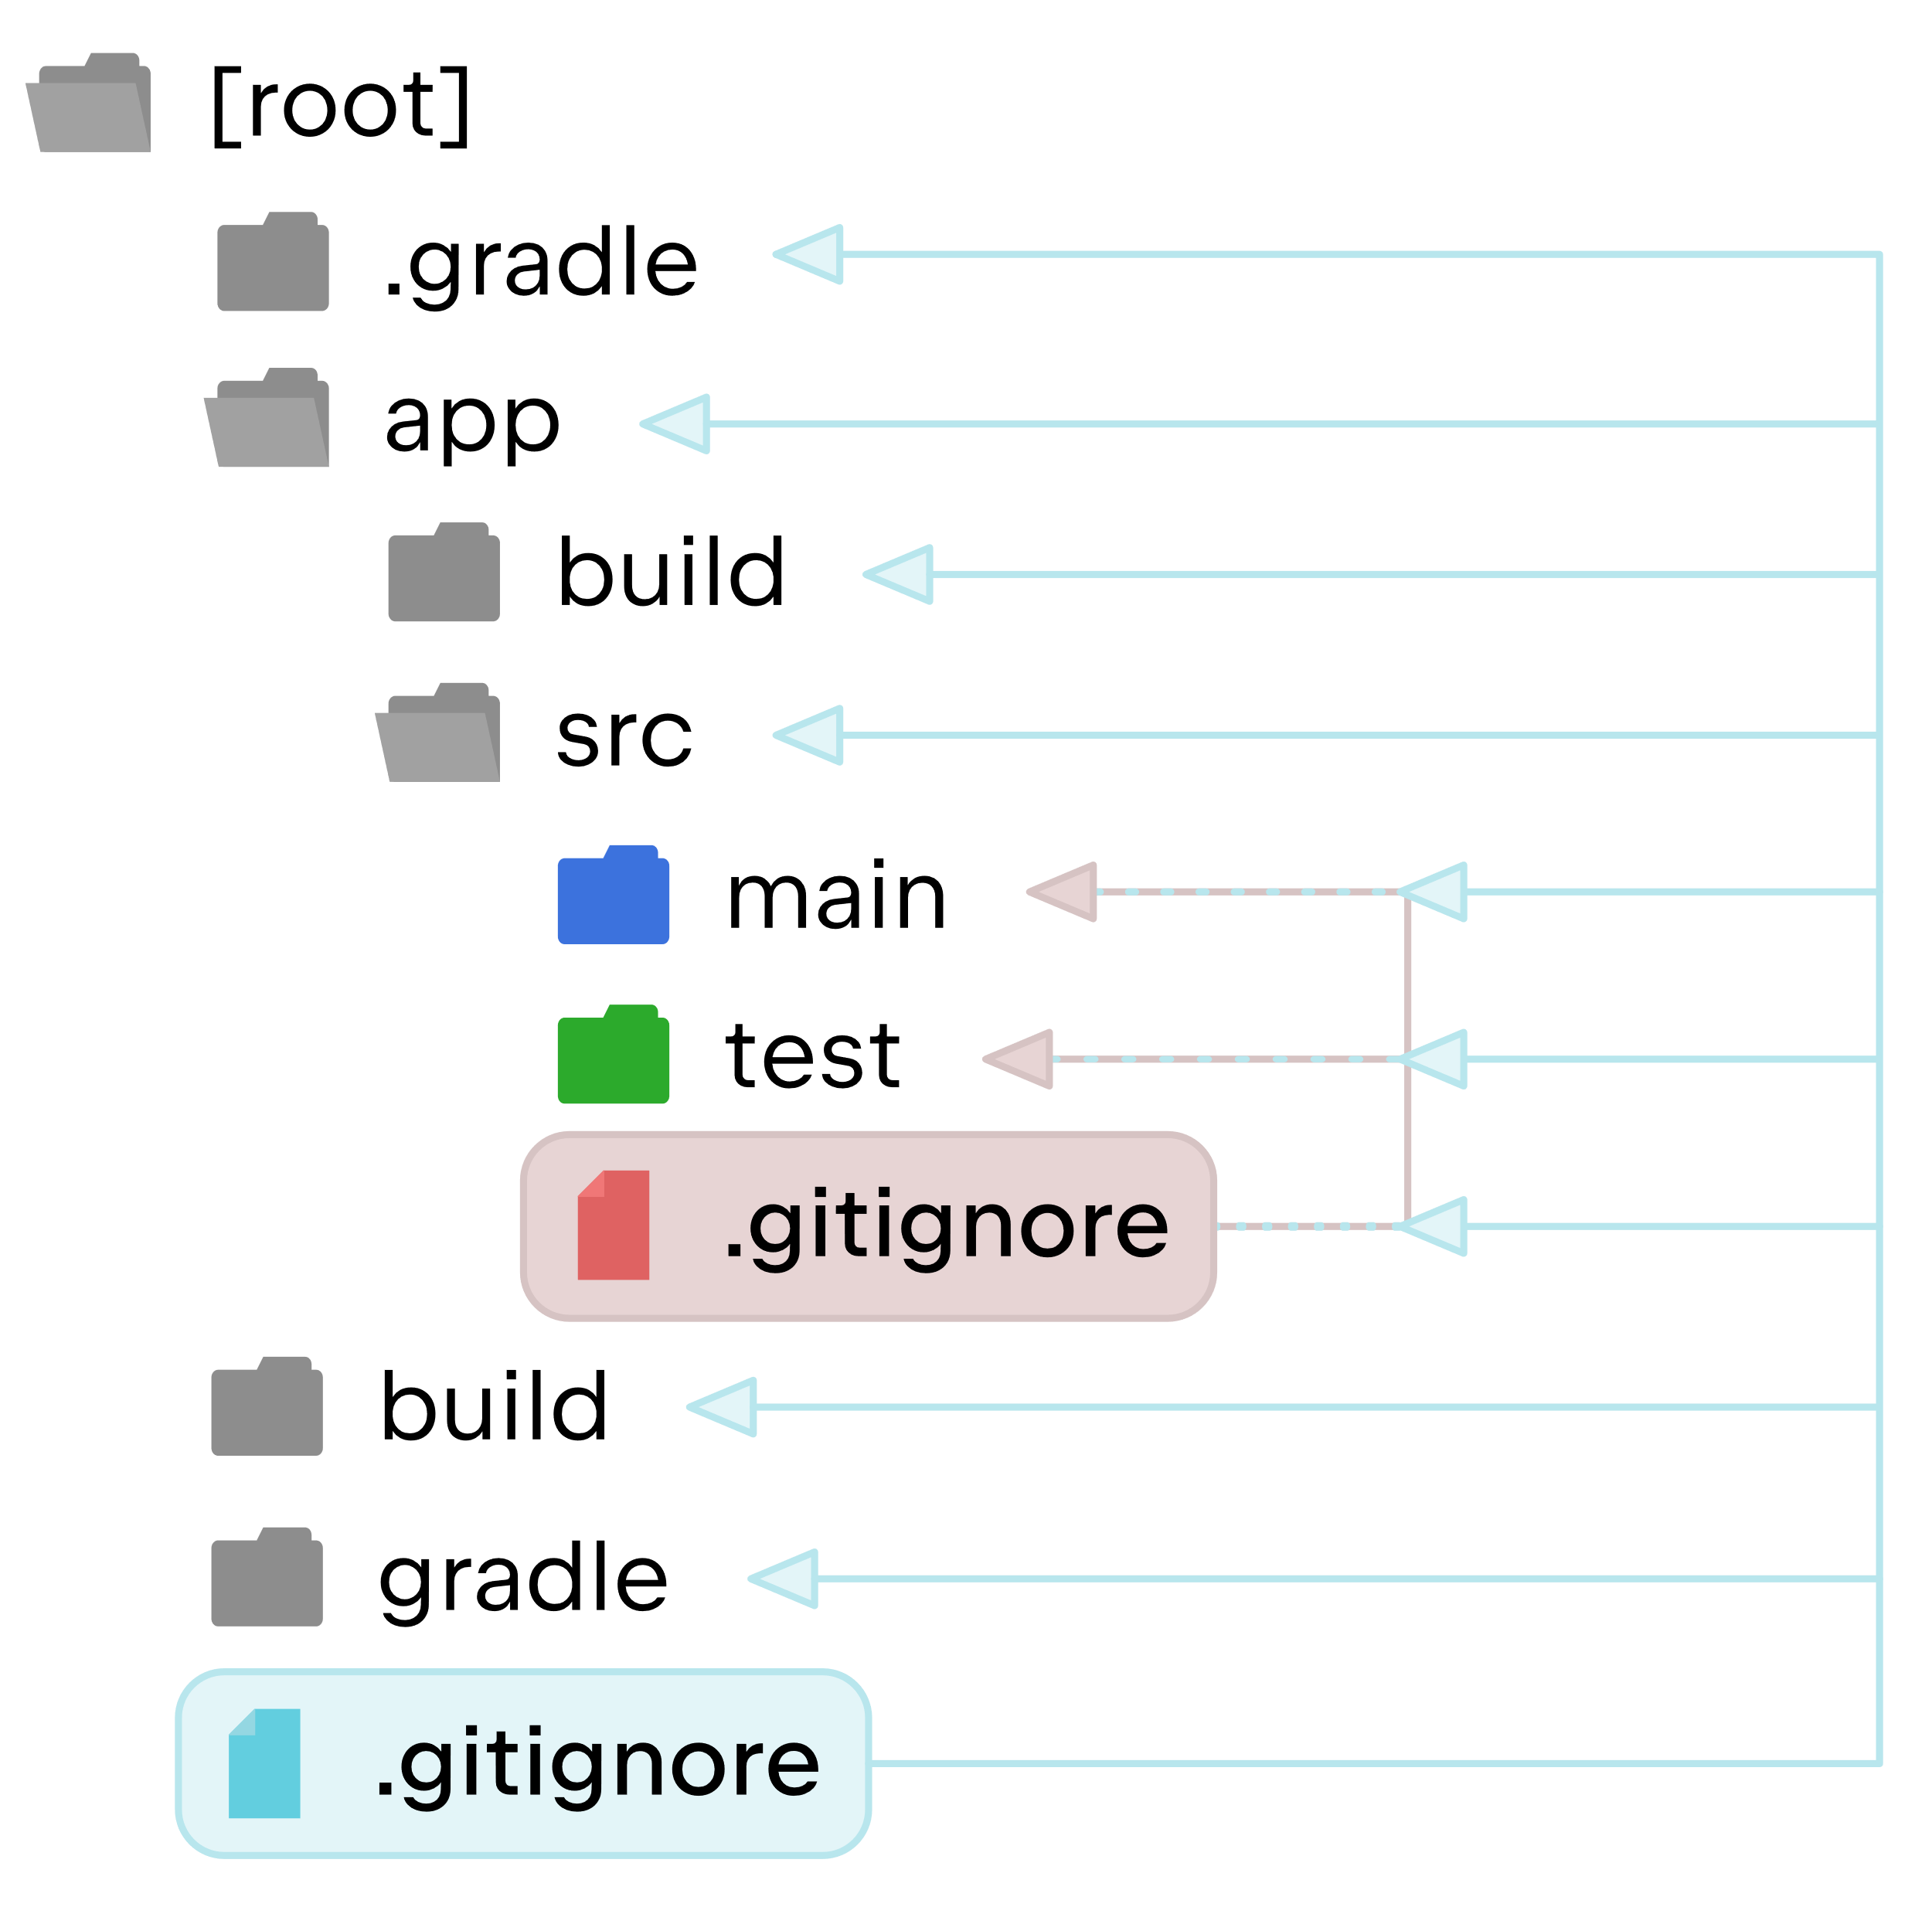

**Wrap Up: Mastering the Art of Deletion**

Deleting data in Git can be a powerful tool for managing your project's history. By understanding the different deletion methods and using them strategically, you can keep your castle's construction zone (working directory) and blueprints (repository) clean and organized.

**Advanced Construction Techniques in Git: Stashing, Reviving, Merging, and Rebasing**

Now that your castle's foundation is laid and you've mastered basic housekeeping, let's explore some advanced techniques for managing your project's history:

**Understanding the Stash ("git stash")**

Imagine you're in the middle of building a magnificent tower (feature) but need to switch tasks urgently. You don't want to lose your progress (unstaged changes), but you also don't want to clutter your current work with them. The git stash command acts like a temporary storage chest for your unfinished work. You can stash your unstaged changes, switch tasks, and then retrieve your stashed work later when you're ready to resume building the tower.

**Algorithm for Using Git Stash:**

1. Run git stash to save your unstaged changes.
2. (Optional) Add a descriptive message with git stash save "<message>".
3. Switch tasks or branches as needed.
4. When you're ready to resume, run git stash pop to retrieve your latest stashed changes.

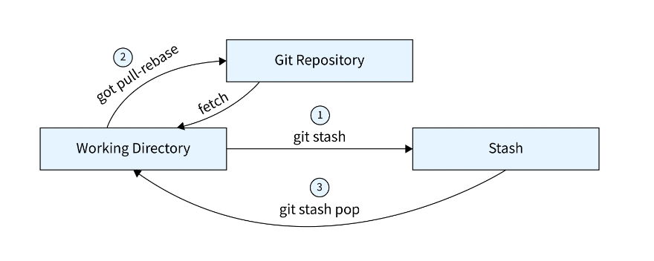

**Bringing Lost Data Back with "git reflog"**

Sometimes, even the most organized architect misplaces something. The git reflog command acts like a detailed logbook of all your Git operations (commits, stashes, branch changes). If you accidentally discard changes or lose track of a specific commit, git reflog can help you find it and potentially recover it.

**Algorithm for Using Git Reflog:**

1. Run git reflog to see a list of recent Git operations.
2. Identify the commit you're looking for by its hash (a unique identifier).
3. Use specific commands like git checkout <commit_hash> or git reset --hard <commit_hash> to recover the commit (use these commands with caution!).

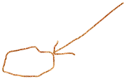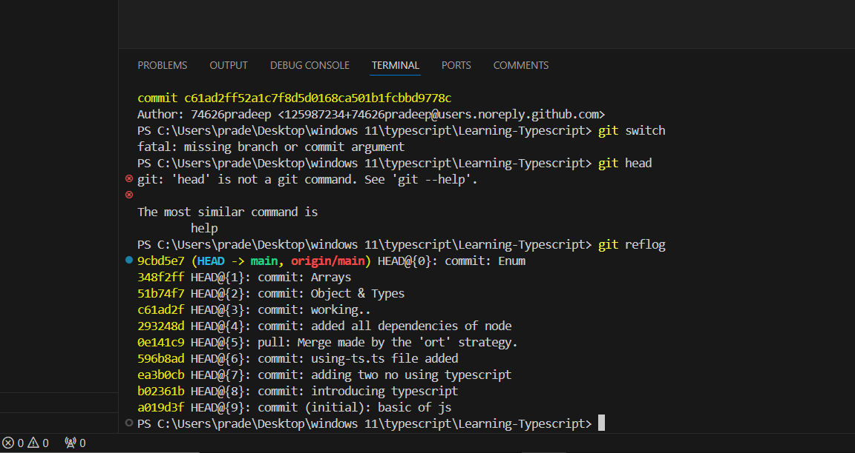

**Combining Branches - What & Why?**

As your castle grows, you might have multiple branches (designs) under construction. At some point, you'll need to integrate the best parts of each branch into your main castle (master branch). This is where merging comes in. Merging is like combining different blueprints (branches) into a single, unified design.

**Understanding Merge Types**

There are two main types of merges:

* **Fast-Forward Merge:** This is the simplest type, where the history of the branch being merged is linear (no branching off). It's like seamlessly integrating a new section of your castle blueprint (branch) into the main blueprint (master branch).
* **Recursive Merge (Non-Fast-Forward):** This occurs when the branch being merged has diverged from the main branch (created branches of its own). It's like merging two separate blueprints (branches) that have been modified independently. In this case, Git might create a "merge commit" to record the merging process.

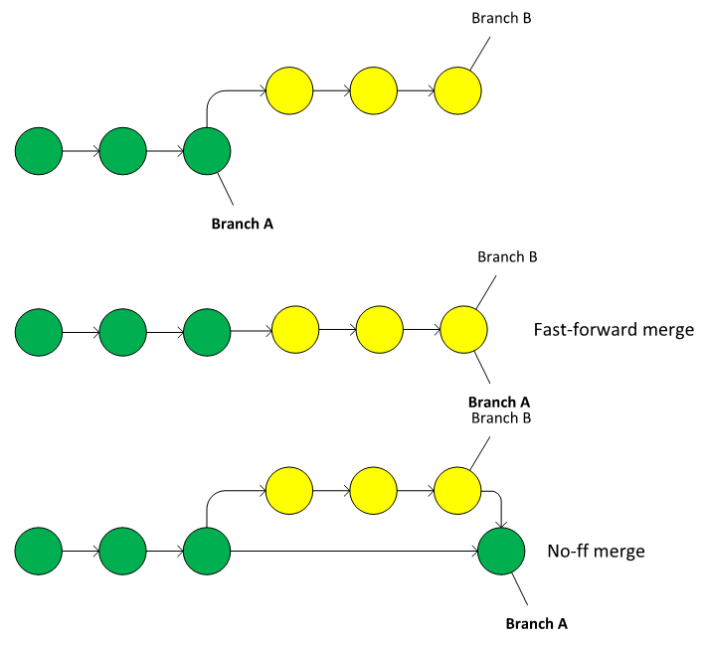

**Applying the Fast-Forward Merge**

When you use git merge <branch_name> on a branch with a linear history, Git performs a fast-forward merge. It's like seamlessly extending your main blueprint (master branch) to include the changes from the other branch.

**The Recursive Merge (Non-Fast-Forward)**

If the branch you're merging has a more complex history, Git will perform a recursive merge. It might create a new "merge commit" to record the merging process and resolve any conflicts between the branches.

**Rebasing - Theory**

Rebasing is a more advanced technique for integrating changes from one branch (usually a feature branch) onto another branch (usually the master branch). It's like rewriting history (carefully!) by taking the commits from your feature branch and applying them on top of the latest state of the master branch. This can result in a cleaner, linear history, but it can also be confusing for collaborators if not used judiciously.

**Applying "git rebase"**

To rebase a branch, you use the git rebase <branch_name> command. Git will replay the commits from your feature branch onto the current state of the master branch, potentially creating new commits in the process.

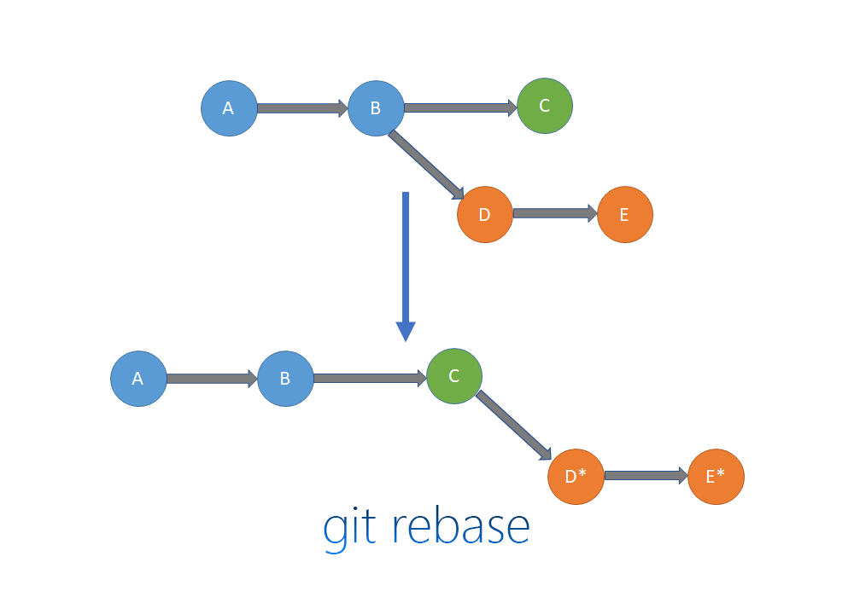

**Handling Merge Conflicts**

Sometimes, when merging or rebasing branches, Git might encounter conflicts. These occur when the same lines of code have been modified differently in both branches. Git will halt the process and present you with the conflicting sections, requiring you to manually resolve them by editing the code.

**Merge vs Rebase vs Cherry Pick**

* **Merge:** This is a more straightforward approach for integrating changes, suitable for simple projects or when collaboration is important. It preserves the history of all branches involved.
* **Rebase:** This can create a cleaner history but can be confusing for collaborators
* Imagine cherry-picking as a treasure hunt for brilliant ideas. You meticulously search through another architect's design (branch) and handpick specific, valuable ideas (commits) to incorporate into your own castle (master branch). This allows you to selectively integrate specific solutions without needing the entire blueprint (branch history).

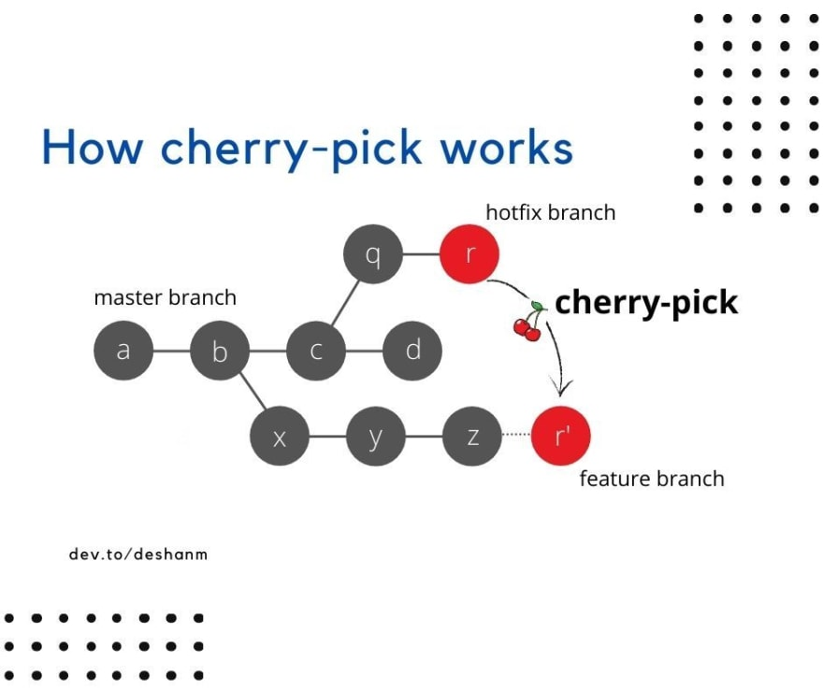

**Cherry-Pick: Selecting the Best Parts**

Imagine cherry-picking as a treasure hunt for brilliant ideas. You meticulously search through another architect's design (branch) and handpick specific, valuable ideas (commits) to incorporate into your own castle (master branch). This allows you to selectively integrate specific solutions without needing the entire blueprint (branch history).

**Algorithm for Cherry-Picking a Commit:**

1. Identify the commit hash (unique identifier) of the commit you want to cherry-pick. Use git log to find it.
2. Run the command git cherry-pick <commit_hash>.
3. Git will attempt to apply the selected commit to your current branch.
4. If there are conflicts (changes to the same lines of code), Git will halt the process and require you to resolve them manually.

**Use Cherry-Pick When:**

* You need to integrate a specific, well-defined change (like a bug fix) from another branch.
* You want to avoid cluttering your main branch history with unnecessary commits.
* You understand the potential complexity of a non-linear history.

**Understanding "git tag"**

**The git tag command allows you to create lightweight pointers that reference specific commits in your Git repository. Think of them as engraved plaques placed at key points in your castle's construction. These tags make it easy to navigate back to those specific versions of your project later.**

**Algorithm for Creating a Tag:**

1. **Use git log to identify the commit hash (unique identifier) of the commit you want to tag.**
2. **Run the command git tag <tag_name> <commit_hash>. Replace <tag_name> with a descriptive name for your milestone and <commit_hash> with the actual hash.**
3. **(Optional) Add an annotation message with git tag -a <tag_name> -m "<message>" to provide more context about the tag.**

**Benefits of Using Tags:**

* **Version Control: Tags act as signposts, allowing you to easily jump back to specific versions of your project for testing, debugging, or reference.**
* **Collaboration: Tags can be helpful for collaborators working on different parts of the project. They can quickly access specific versions based on tag names.**
* **Release Management: Tags can be used to mark releases of your project (like v1.0, v2.1).**

**Remember: Tags are lightweight and don't create new commits themselves. They simply reference existing commits in your history.**